CURRICULUM VITAE

TANIA BERA 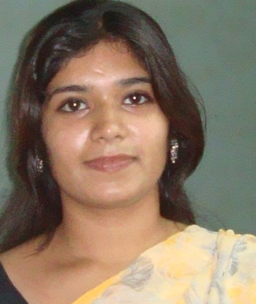

Correspondence Address:
C-43/1, Chalantika, Garia Station Road, Kol-700084(W.B)
: 0332462-7777, Mob: 08013733312
Email ID: taniabera90@gmail.com

Career Objective:

To pursue a career in such an organization, which provides a challenging and friendly work environment and allows me to grow both professionally and as an individual.

Work Experience:

Total experience: 2.8 year.
- Presently working in Airtel as SIC From 5.5.2015 to till date

- 1 year in Shoppers Stop as a customer care associate and fashion assistant From 15.03.2014-1.05.2015

Job responsibilities At Airtel:

- Direct interaction with customers solving their problems time to time

- Handing walk-in customers

- Handling service related issues

- Daily sales collection and & updating records

- Achieving monthly targets

- Verification of documents and scrutinizing

Job responsibilities At Shoppers stop:

- Handle various types of customer issues.
- Should respect customers
- Have to do FIRST CITIZEN LOYALTY PROGRAM as per targets
- Well aware of the offers running at the store
- Good relationship with staffs, seniors and all the co-workers at the store
- Make the Customers know about the facilities they will be getting at the store
- Plan to execute the targets as per the company norms.
- Should have good knowledge about the offers and discounts of the particular brands / department
- Convincing the customer regarding the latest trends.
- Analysis and Interpretation of Customer Tests & Preferences.
- Visual Merchandising Representative

Education:

Undergraduate level
Examination: Madhyamik (10)
Board: West Bengal Board of Secondary Education
Year of passing: 2005
Aggregate: 74.5%

Examination: Higher Secondary (10+2)
Board: West Bengal Council of Higher Secondary Education
Year of Passing: 2007
Aggregate: 71%

Graduation level

Institution: Muralidhar Girls’College
Year of Passing: 2010
Examination: BSC, Calcutta University
Aggregate: 47%

MBA in marketing from EIILM (Batch 2012-2014)

Computer Literacy:

MS-Office

Subject Undertaking in Graduation:

Subject Name: Economics, Mathemetics, Statistics.

Personal Information:

Sex: Female
Marital Status: Unmarried
Father’s Name: Sri Debabrata Bera
Religion/Nationality: Hindu/Indian
Date of Birth: 2nd January, 1990
Language Known: English, Bengali, Hindi

Areas of Interests/Hobbies:

- Driving
- Cooking
- Watching movies
- Listening music

Date:

Signature
Place: Kolkata

